Tonight's Cast

Emcees Tracy & Leif
Trixie Courtney
Frank N. Furter Diego
Brad Majors Tom Amici
Janet Weiss Megan
Riff Raff Steffan
Magenta Laura
Columbia Mandi
Dr. Scott Tim
Eddie Wade
Rocky Jason
Crim Larry
Phantom Paco

Transylvanians

Cheryl Poncho Jesus Peter
Jordan Carlos Kayla

Midnight Mafioso

Stage Director: Brandon Stage Director: Mandi Technical Director: Zac Inventory: Aleah
Tranny Coordinator: Cheryl Webmaster: Bill
Sound: Tracy & Leif Secretary: Aleah
Accountant: Kim Juu Photographers: Liz
Props Foxes: Jo & Shevaun House Manager: Tracy & Drew
Security: Mark, Kay Kay, Jasmine, Fluffy, Data
Merchandise: Jenna, Dakota, Jordan, Amy
Spotlights: Kim, Lara, Christina, Nikkie, Kate
Scenic Tech: Zac, Mit, E van, Eddie, Paco

Denton Times
www.midnightinsanity.org
Hoopla, Denton!! Welcome to another awe inspiring, all encompassing, extravagant eleganza here at Midnight Insanity!!! Tonight is a HUGE show for us. First off, you all better be in the mood for a good old fashioned moustache ride, because tonight we celebrate March Moustache Madness!! That's right, we hope you came decked out in your most ridiculous, sexy, fury upper lip attire, because there will be a contest involved!! Next, we have a very special guest, all the way from the New York cast on the East coast, we have Tom Amici performing Brad Majors for us tonight!!! Thanks for letting us watch you run around in your tighty whiteys, Tommy. Also, a couple other special guests will *pop* up at some point in the show...Jaimie Froemming and Casey Kimble are here to add some sexy to our stage. You'll see what I mean later on...

...And, unfortunately tonight, we have to say goodbye to our long time Criminologist, Larry. He's been with us for a few years now, and he's kicked ass as our resident Narrator. Give him lots of love, and we hope that he comes back real soon!!

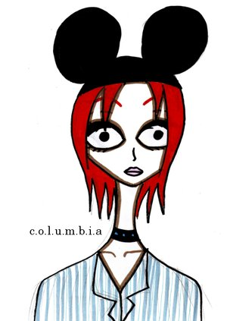

The following weekend, March 12th, be here for a theme night that has been years in the making...Disney Night!! Not only will you see your favorite Rocky Horror characters in Disney garb, but we have a special performance planned that will blow your freaking mind. It's hot. PLUS we'll be having a costume contest. You CANNOT miss this show!!

Like what you see? Want to join the eleganza that IS Midnight Insanity? Well lucky for you, we're always looking for some unsuspecting, innocent young thangs to corrupt. You don't get paid, but you get invited to our kick ass parties, meet some really awesome people, and channel your creativity into something besides your weekly-underwater-basket-weaving-class. So talk to Brandon or Mandi about what you need to do to join our little family...er cult...er cast. Yes, join our happy, harmonious, harmless little cast.
'
Have some suggestions for the show? A theme night you'd like to see? A virgin sacrifice you'd like to watch? Adoring fan mail for our oh so sexy cast members? E-mail us! It's easy, just send your message to: <cast member's first name>@midnightinsanity.org. For example, to tell our sparkly disco ball how much you love her tap dance, just email mandi@midnightinsanity.org!

Brandon's Nonsensical Ramblings:
"It's 22 inches big, he said"

